## 

DAT 515 Final Project

Michael Surdek

Southern New Hampshire University

Third Star Financial Services is an international banking organization that provides money transfer services for individuals who do not belong to standard banking institutions. The company has grown via acquisitions of similar services over the course of the last 50 years but has recently lost marketshare and executive personnel to better-organized competitors. Third Star has many unconnected and incomplete data assets, ranging from customer and agent data to operational reports that vary by location and line of business.

Third Star Financial Services needs to implement an enterprise data management strategy in order to improve its business efforts and remain competitive in the marketplace. The organization requires “a comprehensive Master Data Management solution [which] consists of technology components and services as well as new business processes and even organization structures and dynamics.” (Berson 78) This process would allow Third Star to create a single holistic version of truth that contains data about its customers, agents, and systems, among other things, which would improve the service and operations for Third Star’s customers, agents, and management staff at all levels.

This report will evaluate the current state of Third Star’s enterprise data management systems and recommend a plan for improving and/or overhauling them. The goal of this report is to help key stakeholders and decision makers from Third Star get an idea of what an effective enterprise data management system looks like, what needs to be done to implement it throughout the organization, and how it should be governed once it is in place.

Third Star Financial Services currently has numerous unintegrated systems and applications which attempt to capture and utilize data from its customers and agents, but it does not have a single source of data for its customers. Third Star faces many issues due to this fact, from not knowing the size of its customer base, to duplicate data instances and overall poor data quality. There is also a lack of centralized data governance across the organization. Instead, many individual business units and mid-level managers have taken it upon themselves to ineffectively compensate for this.

Third Star currently has some components of standard enterprise data management which are ineffective for the following reasons:

* Oracle / MS SQL Server database management systems – incomplete data aggregation
* Operating systems varied between UNIX/LINUX and Microsoft Windows – systems and applications vary across business units and locations, leading to inconsistencies
* Hardware supplied by HP and IBM –network and bandwidth issues
* Congos reporting software – lack of data mining and dashboard capabilities

Additional components Third Star must employ to undertake standard enterprise data management include a Data Hub, a governance framework, data quality metrics, metadata management, and reference and master data management. Improving on and adding these components will have positive impacts on the organization’s business processes.

The first and most obvious benefit to operations is the improved workflow for the company’s agents. At the present time, agents do not have access to reliable information about customers. With a golden record of customer data, agents would have new resources to expand their business and to provide better services to their customers. Another group that would benefit would be upper management, who would have new ways to evaluate the agent and branch performance and to identify business practices that leads to improved performance.

Due to ineffective business practices and complexities derived from acquisitional growth, Third Star Financial Services currently does a poor job of gathering, storing, and reconciling data in the customer domain. The first step towards building a golden record of information is designing the following conceptual and logical models of the data requirements for the customer subject area at the transaction level.

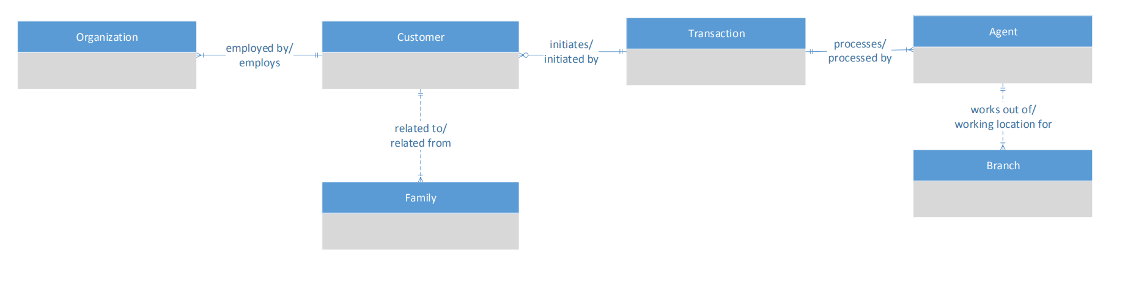

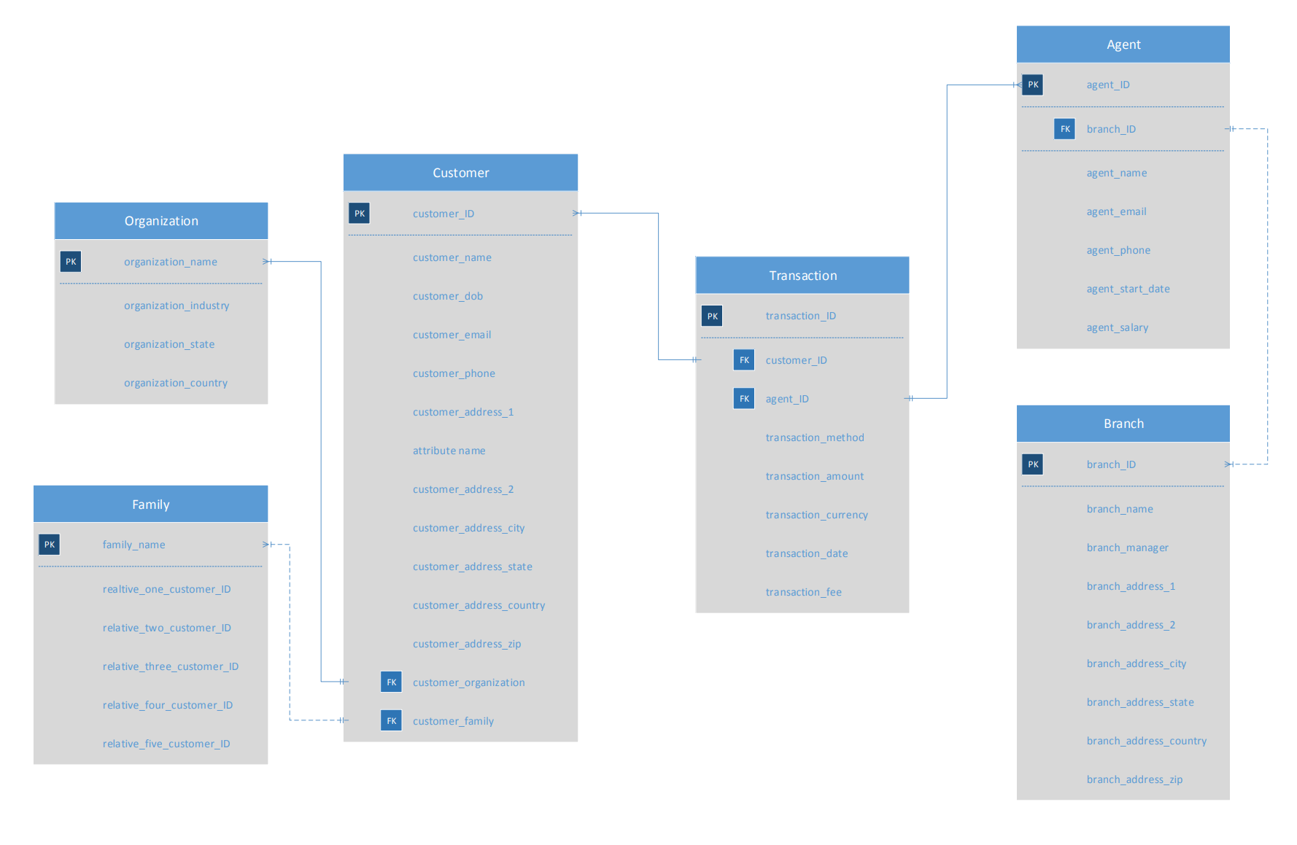

These models contain six entities that might be involved in a given. The model is centered around the Customer entity which contains foreign keys to the Organization and Family entities. These entities will not be required for all customers, but any data gathered in these areas can have benefits such as family relationships or common organizations. The Customer entity is also linked to the Transaction entity via the customer_ID attribute. The Transaction entity is linked via the agent_ID attribute to the Agent entity, which is linked via the branch_ID attribute to the Location entity. It is important for accurate data to be allocated to each of the six transactional entities for both operational and analytical Master Data Management purposes. This will allow agents to access a detailed history of a customer’s transaction patterns, other agents they have worked with, or preferred contact methods. With this in place, agents could offer tailored services to customers as soon as or even before the customer knows they need it.

Now that the data models for the customer domain have been laid out, the next step in the Enterprise Data Management process for Third Star Financial Services is to determine which tools they should utilize as the foundations of their information systems architecture. The first technology I recommend for Third Star Financial Services is Oracle’s Universal Customer Master. This is a Customer Data Hub that provides prebuilt components that integrate customer data from multiple systems. This technology would be key in the process of creating a golden record of data for the company and its business users. Oracle’s Universal Customer Master provides data management processes including matching, customer key management, data enrichment, data synchronization, and analytics. One challenge Third Star will face in the implementation of this technology is due to the numerous and decentralized current sources of customer data. Since the company has grown through acquisitions, the initial data will require a large amount of cleansing and standardization, which will increase financial costs and risks associated with the implementation. I would also recommend based on the DAMA-DMBOK framework that Third Star clearly defines procedures for how new data sources will be referenced against the master data and for how changes to master data can occur through standard business processes.

The second technology I recommend for Third Star is the financial services library from Informatica’s Data Quality Suite. An important component of enterprise data management is the establishment and maintenance of data quality rules. Informatica’s Data Quality Suite provides interfaces and platforms for data stewards and data governance officers that assist with this process. In this case, the financial services industry-specific library of reference data will serve as a useful tool to support Third Star’s data quality efforts. The benefit of improving data quality is that it ensures the resulting information meets the needs of all data consumers within the organization. These improvements span data quality dimensions such as accuracy, completeness, consistency, and reasonableness. Once again, due to the complexity of Third Star’s current architectural state, it will be costly and challenging to perform thorough profiling and analysis, but it is essential to improve the organization’s data management maturity level.

These technology recommendations will require buy-in from all levels of management within the organization. This top-down approach will lead to management providing guidance that facilitates staff involvement in the ongoing enterprise data management processes. This is important because many staff members across the organization will become stakeholders in the data management process, whereas in the organization’s current state, they are partly responsible for their own data and how it is used and managed. Additionally, the customer experience will be impacted by the enterprise data management implementation. At first, the impact will be realized by the fact that individual agents will have systems and processes in place that allow them to provide each customer with the most appropriate experience and services. Down the road, these technologies could provide the foundation for additional technologies that improve the customer experience, such as a mobile application or loyalty program.

There will need to be some ethical considerations in the process of deciding which technologies to utilize. Security standards including access controls, encryption, and auditability must be included in any technology that Third Star considers. In the financial services industry, the protection of personal information is of the utmost priority. This is even more relevant due to the non-traditional banking services that Third Star provides, because some customers might not even expect that their information is being collected. Another consideration is a result of the ever-growing regulatory compliance requirements from legislation such as the Sarbanes-Oxley Act, the Gramm-Leach-Bliley Act, and Basel II, which lay out guidelines and restrictions on financial data and information as well as other operational procedures. Regardless of the technologies that Third Star chooses to utilize, they must provide support for critical data processes such as layered information security frameworks, data protection and confidentiality, intrusion detection, prevention, and monitoring, and a structured process that can keep track of all input and output data to mitigate business risk.

If Third Star Financial Services decides to accept these suggestions, it is necessary that they precisely follow thorough implementation steps from the very beginning up to and through the necessary ongoing management and organizational requirements. The first portion of the implementation is to establish key concepts such as the business case, the initial definition of the MDM roadmap, and the business drivers, objectives, and value propositions for the program and projects. Once these are established, senior management will need communication in regards to “how it will be organized and planned, the major milestones, the cost to develop and deploy, the IT vision, strategy, and resource loaded plans, and the end-state vision across all business and technology domains.” (Berson & Dubov 329) If these steps are followed and communicated accordingly to relevant parties, it will result in the alignment of stakeholders and a unified vision that is logical and realistic for business and IT demands.

Finally, in order to protect customers’ personal financial and identity information, Third Star Financial Services will be required to add a layered security framework which protects data at all levels from the outside in, as well as other restrictions on top of the standard implementation process. This framework spans critical business dimensions such as privacy, confidentiality, integrity, and trust.

To secure the perimeter of the organization, Third Star should install a firewall where secure and insecure networks meet. All network traffic, whether inbound or outbound, will flow through this firewall which protects against many common threats. The security for networks themselves should be provided by a Virtual Private Network (VPN), which establishes an encryption tunnel for users and devices to exchange information. It will also be important to ensure platform security regarding actual devices by only using verified and trusted operating systems, file systems, and servers, and by protecting physical access using secure passwords or even biometrics.

Security in regards to applications, data, and users themselves is best managed by restrictions to access control and other defined entitlements that protect against traditional and emerging security threats. Additional restrictions regarding entitlements and security technologies such as encryption and a Public Key Infrastructure must be implemented. Technologies that include encryption and other conceptual components are an additional level of security at the application, data, and user layers of the framework. Key concepts that Third Star must consider are eXtensible Access Control Markup Language (XACML), Public Key Infrastructure, Policy Enforcement/Decision/Administration Points, and the separation of duties in regards to the enforcement of policy based access control decisions.

Third Star must also take some common data management ethics issues into account to further protect their customers, prospects, and partners. Although it can lead to operational benefits and profit for the company, analytic projects should only be undertaken after thoroughly consider possible negative social implications, such as discrimination. Additionally, Third Star must ensure that targeted marketing and communication does not cross the lines into manipulation or harassment. For this reason, all mass communications must include the opportunity for individuals to change or remove their privacy preferences, which must be directly connected to the customer data hub and incorporated into all necessary programs and applications so that the customer’s preferences are not violated.

If Third Star wishes to remain competitive in the non-traditional banking services industry, the evaluation of the current state of their data management infrastructure makes it clear that a complete overhaul of their systems and business processes is required. Technologies including Oracle’s Universal Customer Master and Informatica’s Data Quality Suite, combined with the conceptual and logical data models, the data governance practices, and the security and ethical considerations laid out in this report will provide the framework required for the organization to increase its enterprise data management maturity level and improve its business processes and the overall customer experience.

References:

Berson, Alex. Dubov, Larry. Master Data Management & Data Governance. McGraw-Hill

Education. 2020.

DAMA International. “The DAMA Guide to The Data Management Body of Knowledge.”

Technics Publications, LLC. 2010.